**Experiment: 3.2 A**

**Student Name: ADITYA RAJ UID:** 21BCS8948

**Branch:** CSE **Section/Group:** 703A

**Semester:** 3rd **Date of Performance:** 09/11/2022

**Subject Name:** DBMS **Subject Code:** 21CSH214

**Aim of the Experiment:** Design a package for HR department as admin to store the details of employees in an organization.

**Program Code:**

CREATE TABLE CUSTOMERS(

ID INT NOT NULL,

NAME VARCHAR (20) NOT NULL,

AGE INT NOT NULL,

ADDRESS CHAR (25),

SALARY DECIMAL (18, 2),

PRIMARY KEY (ID)

);

INSERT INTO CUSTOMERS (ID,NAME,AGE,ADDRESS,SALARY)

VALUES (1, 'Ramesh', 32, 'Ahmedabad', 2000.00 );

INSERT INTO CUSTOMERS (ID,NAME,AGE,ADDRESS,SALARY)

VALUES (2, 'Khilan', 25, 'Delhi', 1500.00 );

INSERT INTO CUSTOMERS (ID,NAME,AGE,ADDRESS,SALARY)

VALUES (3, 'kaushik', 23, 'Kota', 2000.00 );

INSERT INTO CUSTOMERS (ID,NAME,AGE,ADDRESS,SALARY)

VALUES (4, 'Chaitali', 25, 'Mumbai', 6500.00 );

INSERT INTO CUSTOMERS (ID,NAME,AGE,ADDRESS,SALARY)

VALUES (5, 'Hardik', 27, 'Bhopal', 8500.00 );

INSERT INTO CUSTOMERS (ID,NAME,AGE,ADDRESS,SALARY)

VALUES (6, 'Komal', 22, 'MP', 4500.00 );

Select * from customers;

CREATE OR REPLACE PACKAGE c_package AS

-- Adds a customer

PROCEDURE addCustomer(c_id customers.id%type, c_name customers.Name%type, c_age customers.age%type, c_addr customers.address%type,

c_sal customers.salary%type);

-- Removes a customer

PROCEDURE delCustomer(c_id customers.id%TYPE);

--Lists all customers

PROCEDURE listCustomer;

END c_package;

/

CREATE OR REPLACE PACKAGE BODY c_package AS

PROCEDURE addCustomer(c_id customers.id%type,

c_name customers.Name%type, c_age customers.age%type, c_addr customers.address%type,

c_sal customers.salary%type)

IS

BEGIN

INSERT INTO customers (id,name,age,address,salary)

VALUES(c_id, c_name, c_age, c_addr, c_sal);

END addCustomer;

PROCEDURE delCustomer(c_id customers.id%type) IS

BEGIN

DELETE FROM customers

WHERE id = c_id;

END delCustomer;

PROCEDURE listCustomer IS

CURSOR c_customers is

SELECT name FROM customers;

TYPE c_list is TABLE OF customers.Name%type;

name_list c_list := c_list();

counter integer :=0;

BEGIN

FOR n IN c_customers LOOP counter := counter +1; name_list.extend; name_list(counter) := n.name;

dbms_output.put_line('Customer(' ||counter|| ')'||name_list(counter));

END LOOP;

END listCustomer;

END c_package;

/

DECLARE

code customers.id%type:= 8; BEGIN

c_package.addcustomer(7, 'Rajnish', 25, 'Chennai', 3500); c_package.addcustomer(8, 'Subham', 32, 'Delhi', 7500); c_package.listcustomer; c_package.delcustomer(code);

c_package.listcustomer;

END;

/

**OUTPUT:**

The output of the above program is serializing –

1. Creating the table-



1. Inserting the values in the table-

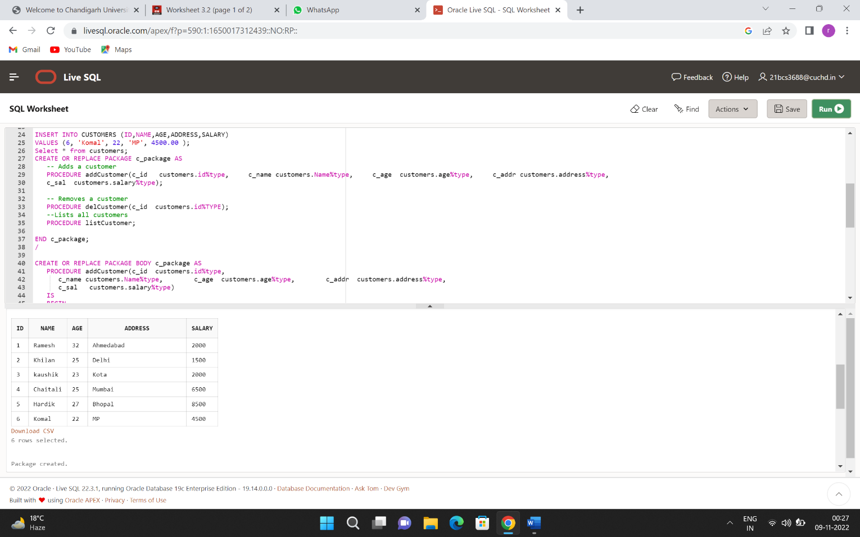

1. Creating a package

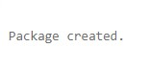

1. Creating a package body



1. Updating the package result-

